**L5 - Install Tomcat web application server in AWS EC2 Ubuntu Instance and access Tomcat using a web browser**

**Step 1: Launch EC2 Instance**

1. **Sign in to AWS Console** 
   * **Go to AWS Management Console**
   * **Navigate to EC2 service**

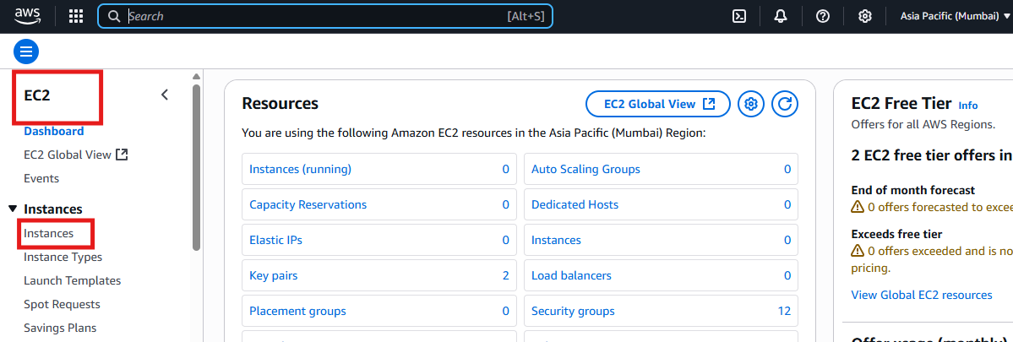

**2.Launch Instance**

* **Click "Launch Instance"**
* **Choose "Ubuntu Server"**
* **Select instance type (t2.micro for free tier)**
* **Choose key pair**

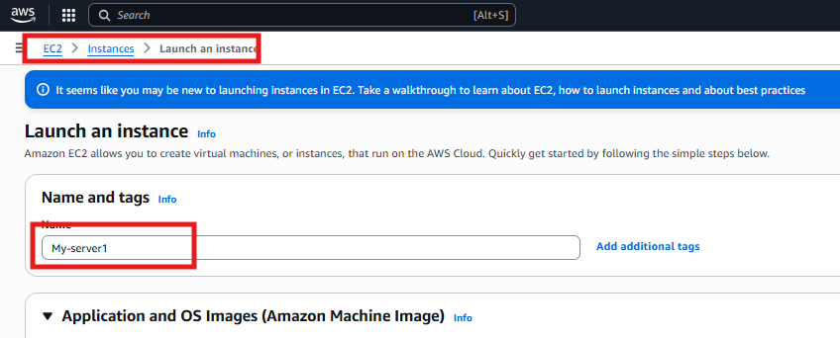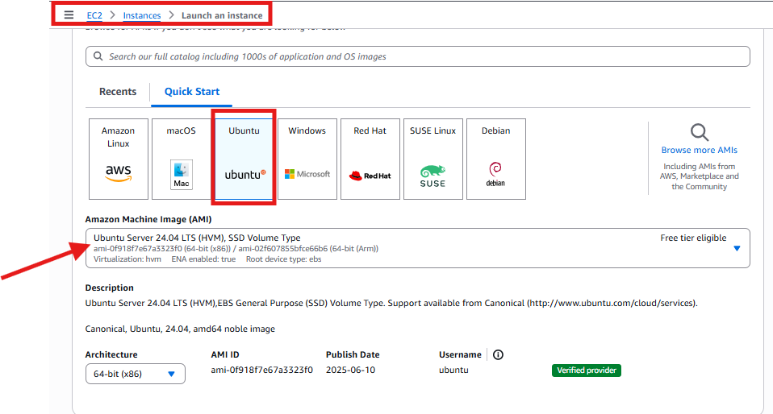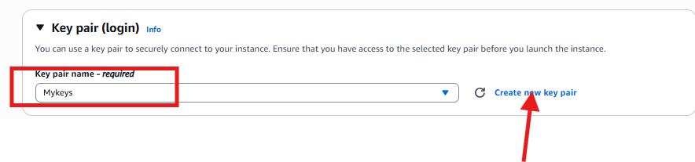

**3.under Network Setting**

**Create a security group or select existing security group**

**Click on Allow SSH traffic from and Allow HTTP traffic from the Internet**

**Configure storage to be kept as default and click on launch instance**

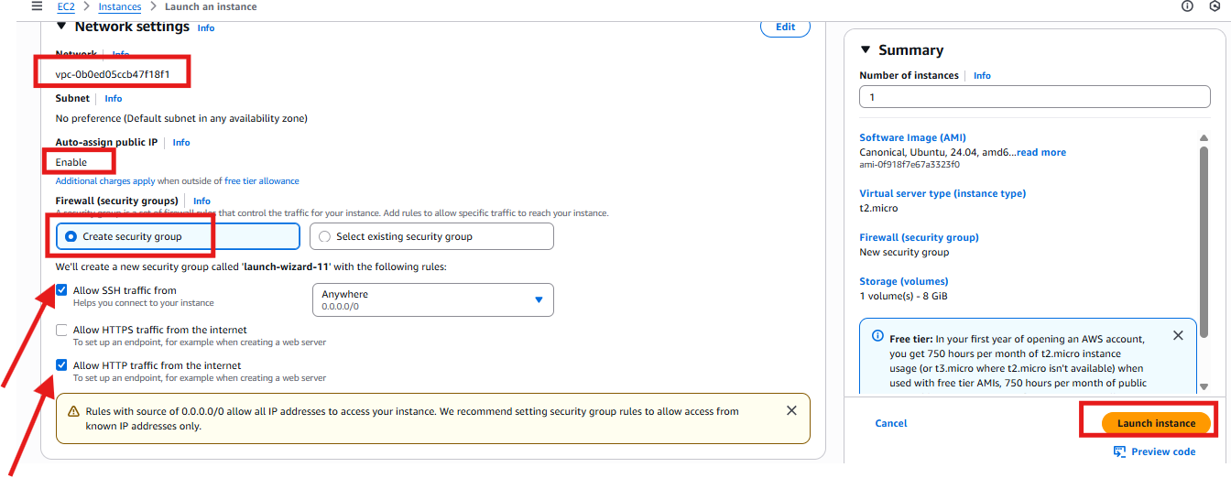

**Custom TCP (Port 8080) added in inbound rules**

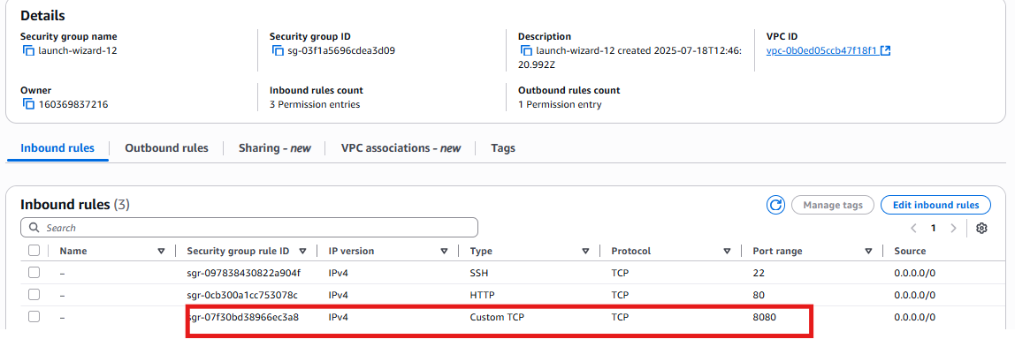

**4.Connect EC2 instance via Putty**

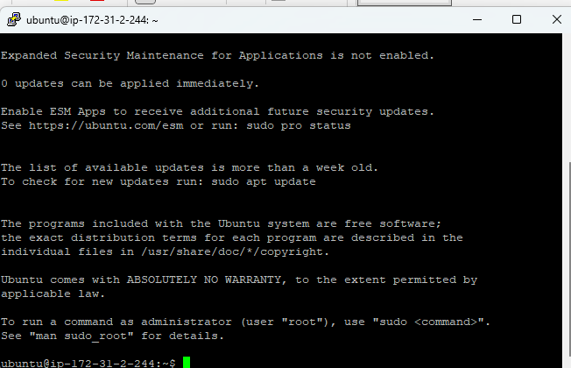

**5.Upate the system packages**

**Sudo apt update**

**Sudo apt upgrade -y**

**6. install JAVA**

**sudo apt install default-jdk -y**

**7. Download and Install Tomcat**

**cd /opt**

**sudo wget** [**https://downloads.apache.org/tomcat/tomcat-9/v9.0.107/bin/apache-tomcat-9.0.107.tar.gz**](https://downloads.apache.org/tomcat/tomcat-9/v9.0.107/bin/apache-tomcat-9.0.107.tar.gz)

**sudo tar -xvzf apache-tomcat-9.0.88.tar.gz**

**sudo mv apache-tomcat-9.0.88 tomcat9**

**sudo chmod +x tomcat9/bin/*.sh**

**8.** **Start Tomcat**

**cd /opt/tomcat9/bin**

**sudo ./startup.sh**

**9.** **Allow Port 8080 in UFW (if enabled)**

**sudo ufw allow 8080**

**10.** **Access Tomcat in Browser**

[**http://65.0.178.58:8080/**](http://65.0.178.58:8080/)

